Meeting | September 2026
Agenda item | Educational visits
Date | July 2026

Trip/ visit location | Sedgeford Dig 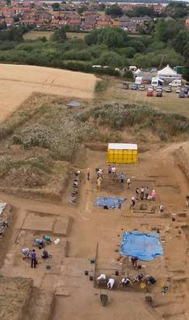
Date of the trip | July 2026
Year group | Year 4
What happened during the trip/ visit? What activities did the children access? | The children spent the day working alongside site experts to discover how people lived hundreds of years ago. It was a hands-on, action-packed trip that brought history and science to life right before their eyes. The children participated in a wide range of interactive stations designed to develop their understanding of past civilizations and scientific analysis:  - Skeleton Discovery  Pupils examined discovered animal and human bones under expert guidance.They learned how archaeologists analyse bone structures to identify different species and deduce clues about health, age, and diet in ancient times.  2. Ancient Crafts & Technology  Children explored how ancient tools, everyday items, and building materials were crafted prior to modern technology.  The session highlighted materials like clay, timber, and stone, illustrating the resourcefulness of historical communities.  3. The Hands-On Excavation Dig  Equipped with archaeology tools, pupils carefully trowelled through designated digging areas. Key Finds: The children uncovered genuine historic remains, including:  Pottery shards and ancient pots, shells, animal bone fragments and daub.  4. Making pottery  The pupils got to make their own hand coiled pot, adding designs and details using natural materials.  5. Exploring in the museum  Alongside a knowledgeable volunteer the pupils explored all the items that had been excavated on the site overtime. Learning about life in the past through he discovered artefacts.
Learning outcomes – how did the trip/visit meet the curriculum objectives. | The visit aimed to bring history, science, and archaeology to life through hands-on activities led by experienced site educators. The trip was a memorable success with brilliant weather, Year 4 returned with greater historical curiosity and a hands-on appreciation for archaeology. The children's enthusiasm was inspiring to see. They demonstrated fantastic curiosity, careful observation, and great teamwork throughout the day.
Cost of the trip / cost paid by parents. | Free
Worth the cost? | N/A
Would the trip/visit be repeated? | The children had a great time, certainly would take them again. They were very keen to invite us back next year and the staff were very complimentary about our pupils.

Photographs of our day out;

